Dear Colleague, Bournemouth, 10 May 2018

WE NEED TO HEAR FROM YOU!

Data protection regulations are changing, and we need you to let us know if you want to continue receiving all our communication. If you love receiving our updates, please respond on this letter to ensure you don't miss out on all the latest inspiration from your Bournemouth Coastal BID!

The following record on our database is relevant regarding legal notifications about the Bournemouth Coastal BID Ltd.
Please check your data carefully that all information is correct.

Address of the business:

Business contact:

Voter contact details:
Voter (in capital letters):

Property address:

Additional information
Website:
E-mail:
Mobile number:
Landline number:

Bournemouth Coastal BID 1st Floor, Burlington House, Burlington Arcade, St Peters Road, Bournemouth BH1 2HZ
stefan@coastalbid.co.,uk 01202 291200 www.coastalbid.co.uk
Company Registration Number: 8101644 Registered in England VAT No: 139 4327 04
Registered Office: Dean Park House, Dean Park Crescent, Bournemouth BH1 1HP

Please tick the boxes below the ways you would like to hear from us:

EMAIL

DIRECT MAIL

PHONE

FACE-TO-FACE (by appointment)

Please inform us of your interests to receive further information:

BUSINESS SUPPORT

BUSINESS MARKETING & PROMOTIONS SUPPORT

COASTAL DISTRICTS PROJECTS AND EVENTS

Thanks for opting in to receive our latest news, updates and offers. As we’re initiating some of the most exciting and successful activities in the Bournemouth Coastal BID districts, we want you to continue benefitting from all projects and services the Coastal BID has to offer your business.
Please note: You can change your mind at any time by notifying the Coastal BID team (office@coastalbid.co.uk) if you want to opt-out of receiving information.

Our CBID Newsletter will provide you with up to date information, ideas and solutions for your business. We provide a voice for all people passionate about their place. Businesses and place management practitioners across the Bournemouth Coastal District promote their work, learn from others and help shape future local policy.
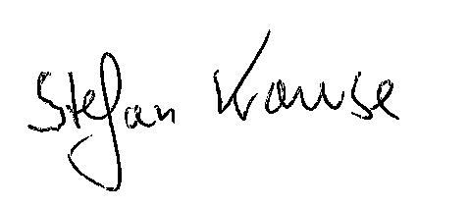
Best regards,

Stefan Krause Annette Plaistow-Trapaud
Coastal BID Manager Business Liaison

………………………………………………………………………………………………………………………

RETURN THIS FORM BY POST TO or scan and email: office@coastalbid.co.uk

Bournemouth Coastal BID
1floor Burlington House
Burlington Arcade
St Peter’s Road
Bournemouth BH1 2HZ

