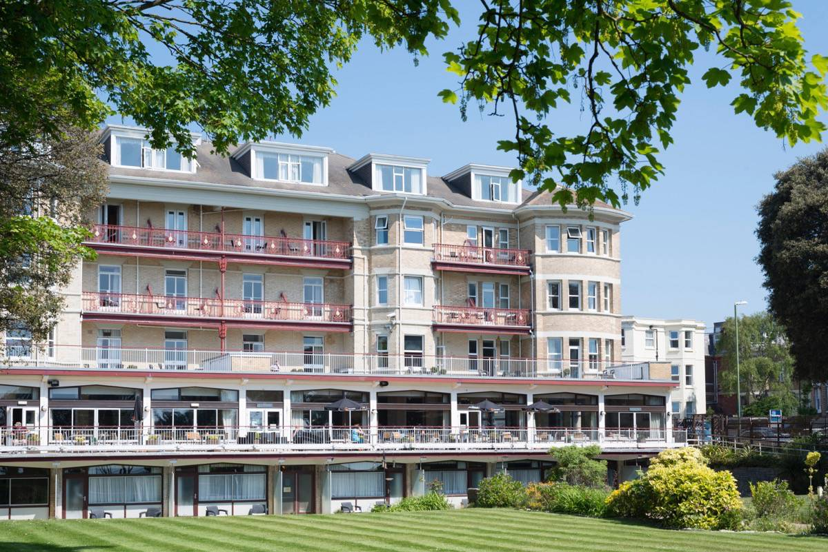
Savoy Summer Fair 2018
In conjunction with Westbourne Rotary
Date: Saturday 26th May 2018
Time: 10.00am – 4.00pm
STALL/PITCH APPLICATION FORM
(Note -NO catering pitches are available at this event)

This application form includes general terms and conditions. Please read through document carefully before completing your application as by signing the application, you are agreeing to be bound by all its terms and conditions.

General Information:
- Exhibitor/stallholder pitches will be allocated a standard 3m x 3m pitch and should bring their own table/gazebo to the event.
- Stall holders must note that there is no access for vehicles to the site and all rubbish must be removed at the end of the event.
- All gazebos must be securely erected and secured and any guide ropes clearly visible to avoid any trip hazard.
- In addition to Westbourne Rotary and Savoy Hotel stalls - a maximum of 6 stands will be allocated to registered charities on a free of charge basis – but the charities allocated charity stall status are required to offer a free activity for children in exchange for the free stall space.
- All other stalls are offered on the basis of a £10 charge per stall which will be donated to charity - TBC

How to Apply:
- Complete all relevant parts of the application form fully, signed and dated.
- Send completed application form – include a copy of your risk assessment, public liability insurance (and products, if applicable) and employer’s liability insurance (if required by law)
- Send your application form and other information by email to info@westbournerotary.org.uk or by mail to: Rotary Club of Westbourne, 282 Malmesbury Park Road, Bournemouth BH8 8PR

Person or Organisation Name
Charity No (if relevant)
Contact Address
Contact Name:
Contact Tel No  During fete | Landline: Mobile
Email address for fete correspondence
Type & Size Pitch  (Indicate size of pitch required) | Standard Pitch: 3’ x 3’ If available - Do you require the hotel to  supply a trestle table for your stall?  YES  Number of pitches required  NO
Please detail all products or services to be exhibited/sold
Where did you hear about this event | Website: Facebook: Friend: Newspaper: Flyer/Poster:  Other: Please give details:
Signed:  Print Name | Date:
Exhibitors Health & Safety Questionnaire

Please give details of the person who will have overall responsibility for health & safety on your pitch and provide a copy of your risk assessment | Name:  Mobile Tel No:
Please give details of all equipment that you wish to bring on to the site
Please note – generators are not permitted on site without prior notification and agreement
Please confirm that all equipment listed above has been tested and serviced in accordance with relevant regulations, and that current test certificates are attached and will be available for inspection on the day. | Yes No
Will your staff or the public have access to potentially hazardous equipment, or parts of it?  If yes – please provide details in the risk assessment of control measures that will be put in place to minimise the risk of injury | Yes No
Will your stand involve the use of moving equipment?  If yes – are all your staff fully trained in its use | Yes No  Yes No
Please provide Public Liability Insurance details  (This is a requirement for the event) | Insurer’s Name:  Amount £ (min £5million) £  Expiry Date:
Please provide Employers Liability Insurance details (if relevant) | Insurer’s Name:  Amount £ (min £5million) £  Expiry Date:
Will your stand consist of more than five members of staff at any one time? | Yes No
Signed | Date

CHECK LIST for APPLICATION DOCUMENTS:

Application Form – full completed and signed

Payment – cheque payable to ‘Rotary Club of Westbourne’

Health & Safety Questionnaire – fully completed and signed

Risk Assessment – an updated and current assessment of risks

Public Liability Insurance Documentation – (if relevant) - current valid policy

Employers Liability Insurance Documentation (if relevant) – current valid policy

SEND ALL ABOVE INFORMATION TO:

By E-mail – info@westbournerotary.org.uk
By post (marking envelope with ‘Savoy Summer Fair’ to:
Rotary Club of Westbourne
c/0 282 Malmesbury Park Road
Bournemouth
Dorset BH8 8PR

Terms & Conditions

- The organiser of this event is taken to mean the Savoy Hotel, in conjunction with the Rotary Club of Westbourne that meets weekly at the Savoy Hotel

- Bookings will only be confirmed on receipt of all the required documents fully completed and signed and relevant payment.

- The organisers reserves the right to reasonably refuse any Application at its sole discretion.

- Exhibitors will be allocated a pitch within site area and the organiser will advise the exhibitor of its allocated pitch on arrival. Change/Exchange of pitch by exhibitors on arrival or during the fete is NOT permitted. However, the organiser has the right to request an exhibitor to move to another pitch and to change the layout and location of the pitches without prior notice.

- The organiser, or its authorised representatives, must be permitted access to all pitches at all times throughout the day of the fete.

- All pitches are on grass and may be affected by weather conditions on the day, which may range from dry/dusty to wet/windy.

- Exhibitors are solely responsible for ensuring the pitch booked is of sufficient size to accommodate their equipment, including gazebos.

- Exhibitors will not be permitted to have any equipment overhanging or extending beyond the area of their allocated pitch.

- Stands may be secured to the pitch by pegs but these pegs must not damage the surface of the grounds

- Exhibitors must leave their pitch in the condition in which they found it. Exhibitors will be liable to pay the organiser the full cost of repairing any damage caused by the Exhibitor to their pitch.

- Exhibitors are prohibited from transferring or assigning their allocated pitch to a third party.

LITTER AND REFUSE
- Exhibitors are solely responsible for keeping their pitch tidy, including collecting litter and refuse regularly and removing all rubbish from site at the end of the event.

- Exhibitors who leave litter or rubbish behind at the end of the fete may be charged by the organiser for the removal of such rubbish.

SET UP AND BREAKDOWN OF STANDS ON THE DAY
- Setting up of stands will be available from 08.00 on the day of the event and breakdown should not take place until after the end of the event at 16.00, unless otherwise approved by the organisers.

- Exhibitors should report to Rotary organisers on arrival at the event in order to be directed to their pitch and should be aware that there is no vehicle access to the site.

CAR PARKING
- There is only limited car parking available at the hotel for hotel guests so exhibitors/stall holders must remove their cars to an alternative parking area. Council car parks are available in West Hill Road and also West Cliff Road.

SECURITY
- The organiser has the right to undertake any security checks it reasonably considers necessary. At its sole discretion, the organiser may refuse entry to the site to any persons, or ask persons to leave the site.

- The organiser will not be responsible for or accept any liability for any party’s personal items, property or equipment on site. Exhibitors are strongly advised to ensure they have adequate insurance in place to cover such items and to take all reasonable care of their items and equipment on the day of the event.

HEALTH & SAFETY
- Exhibitors are solely responsible for and liable for any equipment brought onto site and for ensuring all relevant insurances are obtained and all contractual obligations met.

- Exhibitors marquees and gazebo structures must be compliant with fire safety regulations and must be safely erected and secured before the start of the fete.

- Exhibitors are responsible for the health, welfare, safety and security of all members of the public whilst on their pitch or stand.

- Exhibitors must ensure that their equipment is fitted with suitable guards and safety devices, where relevant, and properly maintained in accordance with official guidelines.

- The organiser reserves the right to reasonably request an exhibitor to cease any activity or close any exhibit or to leave the site, if the organiser deems the exhibitor’s activities or any part of them is unsafe or poses a risk to the general public, or does not confirm to relevant legislation and/or these terms and conditions.

- In the case of an emergency, exhibitors must notify the organiser immediately and follow the emergency procedure required by the organiser and/or emergency services. Exhibitors are responsible for assisting the organiser with the safe removal of all persons from site, whilst ensuring that routes are kept clear for access by emergency services.

EXHIBITORS STANDS
- Exhibitors must ensure they bring everything needed for their pitch as no equipment will be provided by the organiser unless organised and confirmed in advance.

- Exhibitors must man their stands from 10.00 – 16.00 on the day of the fete.

- Exhibitors are not permitted to dismantle stands or any part of them prior to 16.00 on the day unless agreed with the organiser.

- Exhibitors are prohibited from using microphones or amplifiers or from calling out to the public to attract their attention to their stands. The organiser has the right to demand removal of any such equipment found on the site.

- Exhibitors, as previously detailed, must store and remove all rubbish from site at the end of the event.

- Exhibitors will be solely responsible for the cost of making good any damage they cause to any other exhibitors stand.

NO FOOD OUTLETS
- The hotel will be organising food and drink provisions at the fete and therefore no catering outlets will be allowed on site and any application will be declined unless previously agreed with the organisers and hotel management.

GENERAL SITE PROVISIONS
- The organiser reserves the right at its sole discretion to reasonably refuse an Exhibitor entry to the site or revoke permission given to an Exhibitor to enter the site.

- Exhibitors are not permitted to sell items from anywhere other than their pitch except where consent has been sought from and given by the organiser prior to day of fete.

- No drinks will be provided to Exhibitors but drinks are available to purchase from the hotel bar.

- The organiser will not provide any storage facility for Exhibitors equipment or stock.

- The Savoy Hotel is an operational hotel so no overnight sleeping or camping is permitted on site of event.

- Exhibitors must not, at any time, cause any obstruction of routes, gangways, pathways or open spaces on or near the site.

- Exhibitors must remove all of their equipment and other items, including rubbish, from the site at the end of the event. If the organiser is left to clear any exhibitors equipment or other items left on site, the organiser will have the right to recover from the Exhibitor, as a debt, the cost of removing any such equipment or other items.

LIABILITY AND INSURANCE
- Exhibitors accept that they participate in the fete at their own risk.

- Exhibitors are responsible for ensuring that all items sold by them comply fully with UK and European consumer laws with regards to safety, fair trading, price display, food and weights & measures. Any services provided and statements about services provided must comply with trading standards legislation.

- Exhibitors must not sell any goods that infringe any third party copyright or trademark.

- Exhibitors are liable for any faulty, damaged or misrepresented items sold by them. The organiser will not accept any responsibility or liability for any contractual obligations of Exhibitors. In the event of a dispute between an Exhibitor and a consumer, the organiser has the right to pass the Exhibitors business contact details to the consumer.

- Exhibitors are required to display full details of the owner of the business on their stands. Exhibitors who fail to do so may be asked by the organiser to cease trading and/or leave the site.

- Exhibitors are advised to take out insurance cover for the day of the fete to cover potential cancellation or curtailment of the event.

- Exhibitors are responsible for checking whether they need to obtain any licences and/or consents to trade at the fete, for example a street trading license. If such licenses or consents are required, it is the Exhibitors sole responsibility to apply for and obtain the necessary license and/or consents prior to the day of the fete.

- Exhibitors shall not do, or omit to do, and shall make all best efforts that their staff, agents and contractors do not do or omit to do, anything that would or could result in the organisers licenses being revoked or insurance being void or voidable or in insurance premiums being increased, relevant to the fete.

- Exhibitors will fully indemnify and keep the organiser indemnified against all actions, claims, costs, including legal fees, expenses and liabilities arising under statute or common law from:-
- Injury to or the death of any person; and/or
- The loss of or damage to any property including property belonging to the organiser or any third party; and/or
- Any breach of the Exhibitors obligations; insofar as they arise under these terms and conditions or as a result of any act, omission, default or negligence by the Exhibitor or its staff or contractors.

- Without prejudice to the Exhibitors liability detailed previously, exhibitors shall obtain and maintain appropriate insurance policies with reputable insurers in such sum as is deemed prudent in all circumstances by the Exhibitor, but in any event with the minimum limits of indemnity specified below:-
- Public liability insurance (including products liability if selling any products) of £5 million each and every incident; and
- Employers liability insurance (if required by law) of £5 million each and every incident

- Exhibitors must provide evidence of the required insurance cover with their Application. Where such insurance cover is due to expire prior to the date of the fete, evidence of renewal of such cover must be provided to the organiser before the fete. Exhibitors must be able to produce evidence of insurance cover when requested by the organiser at any time prior or during the date of the fete.

- The organiser will not be liable for any actions, claims, costs, expenses and liabilities incurred by Exhibitors as a result in participation at the fete.

- Exhibitors must comply with all regulatory requirements current at the date of the fete

GOVERNING LAW
- These terms and conditions will be governed by and interpreted in accordance with English Law and the parties submit to the exclusive jurisdiction of the courts of England.

